**User Manual**

Java Bomberman

Alex Chen, Kevin Chen

5/29/15

1. **Introduction**

Bomberman is a popular and well-known game franchise with many different iterations and versions. While many versions contain single player and arcade game modes, every version includes the classic free-for-all multiplayer game mode. This project is an attempt at recreating the traditional multiplayer mode completely using Swing and Graphics in Java. While the program is not an exact equivalent of the game, it contains all the same logic and mechanics, though it may be slightly limited.

1. **Purpose**

Java Bomberman was created as the final project for the course Computer Science III. The creating of the project also served the purpose of helping to expand our knowledge and experience with the computer programming language Java. As it is a game, the project itself serves the purpose of providing visual entertainment while allowing user interaction. This manual will help guide the reader through how to use and play the Java Bomberman program.

1. **Using the Program**

3.1 The Start Screen

The start screen of the program (shown below) is the screen that first appears after running the program. The start screen serves as a menu with three possible options: Play Game, How to Play, and Controls. To navigate through the different options, use the arrow keys. To select an option, use spacebar.

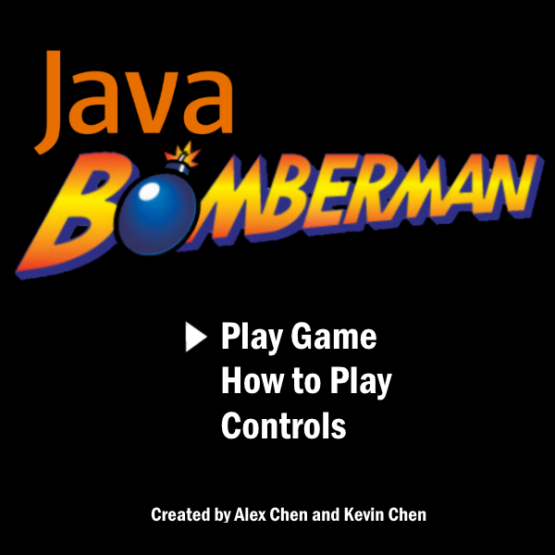

Start Screen

3.2 How to Play Screen

Selecting “How to Play” on the start screen brings you to the how to play screen. The how to play screen, as its name suggests, simply informs the user of the basic rules and the goal of the game Bomberman. The rules detailed are as follows:

-Move around with up, down, left, and right

-Drop Bombs to destroy blocks and eliminate opponents

-To win, eliminate all other players

-Collect the powerups shown below to improve various attributes

The screen also includes the icons of the three powerups present within the game and the effect that each has on the player.

To exit the how to play screen and return to the start screen, hit backspace or space.

3.3 Controls Screen

Selecting “Controls” on the start screen brings you to the controls screen, which lists the up, down, left, right movement keys as well as the drop bomb key for each of the four players.

To exit the controls screen and return to the start screen, hit backspace or space.

3.4 Play Game Screen

Selecting “Play Game” on the start screen brings you to the play game screen, which has three further options, 2 player, 3 player, and 4 player. Each option starts the game with however many players it states. Use the spacebar to select an option.

Note: there is no 1 player option as this game requires at least two players.

To exit the play game screen and return to the start screen, hit backspace.

3.5 Playing the Game

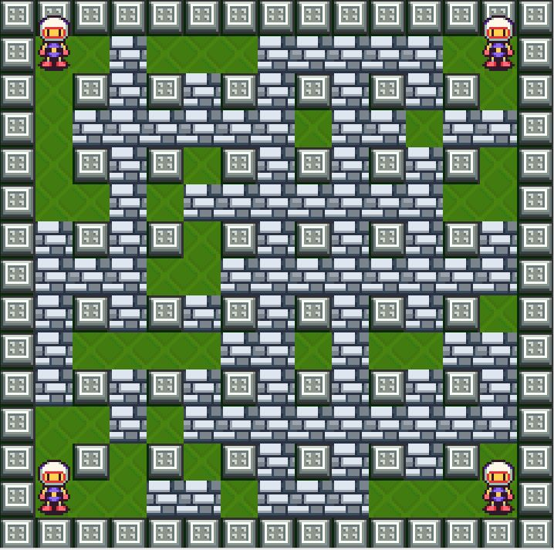

Game Screen with 4 players

Once you select one of the three options on the play game screen, you will be taken to the game screen that consists of the map, which is 15 blocks on each side, and however many players you selected. Player1 starts in the top left corner, player 2 starts in the bottom right corner, player 3 starts in the top right corner, and player 4 starts in the bottom left corner. Now, play the game using the controls from the controls screen and following the rules and guidelines from the how to play screen.

To exit the game screen and return to the play game screen, hit backspace.

1. **Key Features**

4.1 The Game Mechanics

The game mechanics are key features of the program as they required a lot of code and several object classes. The program’s mechanics closely resemble that of the actual game. Aspects of the game mechanics that were tricky included those that required usage of a timer, such as the explosion of the bombs and the path of fire left by the bombs. The key to implementing these mechanics is a constantly running timer that increments the int variable time and keeps track of attributes such as when bombs are dropped.

4.2 The Game Graphics

The game graphics are also key features of the program as they too were code-heavy. Most of the graphics in-game are animated to a certain degree, such as the players walking, the pulsating of dropped bombs, and the appearance and disappearance of the path of fire created by bombs.